BLOOMBERG NEW
CONTEMPORARIES
5 DEC 2018 – 24 FEB 2019
MAIN GALLERY, FIRE STATION GALLERIES 1, 2 & 3
ADMISSION FREE

LARGE PRINT EXHIBITION GUIDE

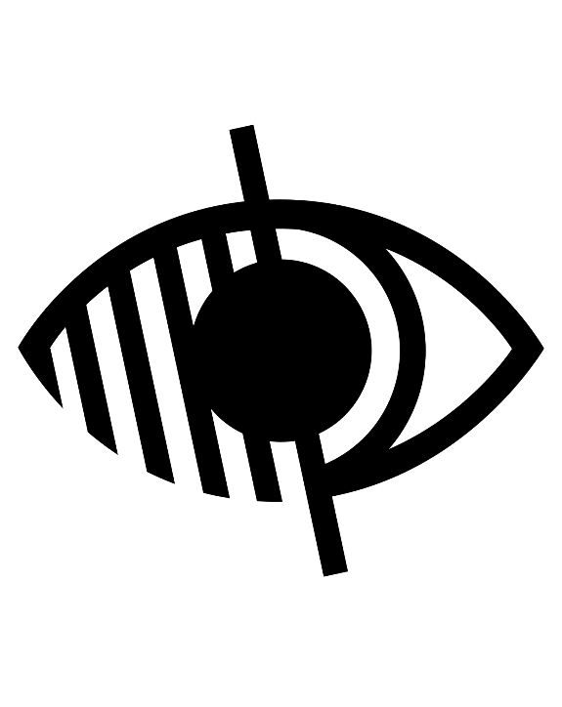

Bloomberg New Contemporaries
5 Dec 2018 – 24 Feb 2019

Bloomberg New Contemporaries 2018 at the South London Gallery (SLG) is the second exhibition to be presented across the main building and the recently opened Fire Station. Returning to the SLG for the first time in nearly 20 years, the annual open submission exhibition was last presented at the gallery in 1999.
New Contemporaries is the leading UK organisation supporting emergent art practice from British arts education. Participants are selected by a panel comprising influential artists and art world figures who consider the work within a broad cultural context.
Bloomberg New Contemporaries 2018 selectors Benedict Drew, Katy Moran (New Contemporaries alumni 2006) and Keith Piper (New Contemporaries alumni 1986) have chosen 57 artists for this year’s show. This is the first year
that Bloomberg New Contemporaries includes artists from non-degree awarding courses. Presenting a curated cross-section of drawing, painting, sculpture, installation, performance
and video, the works on show address issues ranging from migration and borders, cultural
and gender identity through to the use of technology.

The selected artists are Agil Abdullayev, Kobby Adi, Ayo Akingbade, Annie-Marie Akussah, Chris Alton, Louis Bennett, Jack Burton, Christian Noelle Charles, Kara Chin, Faye Claridge,
Jack Fawdry Tatham, Emma Fineman, Rhona Foster, Deme Georghiou, William Glass, Carrie Grainger, Madelynn Mae Green, Habib Hajallie,
Camilla Hanney, Rebecca Harper, Sam Henty, Mimi Hope, Richard Ayodeji Ikhide, FC Izaac, Osian Jenaer, Patrick H. Jones, Jessica Jordan-Wrench, Marianne Keating, Gareth Kemp, Yushi Li, Shao-Jie Lin, Heidi Maribut, Alexi Marshall, Jocelyn McGregor, Holly McLean, Paula Morison, Yuko Obe, Kamile Ofoeme, Panicattack Duo, Jack Pell, Ralph Pritchard, Anna Reading, Maïa Régis, Bella Riza, Francisco Rodriguez, Janet Sainsbury, Mohammed Sami, Antonia Showering, Shy Bairns, Wal Slzr, Tom Smith, Alcaeus Spyrou,
George Stamenov, Viviana Troya, Rosa Johan Uddoh, Tom Waring and Yanghwa.
Bloomberg New Contemporaries 2018 launched on 14 July 2018 at Liverpool School of Art & Design, Liverpool John Moores University, as part of Liverpool Biennial 2018.
#newcontemps #slgnewcontemps

Main Gallery

65-67 Peckham Road
London
SE5 8UH

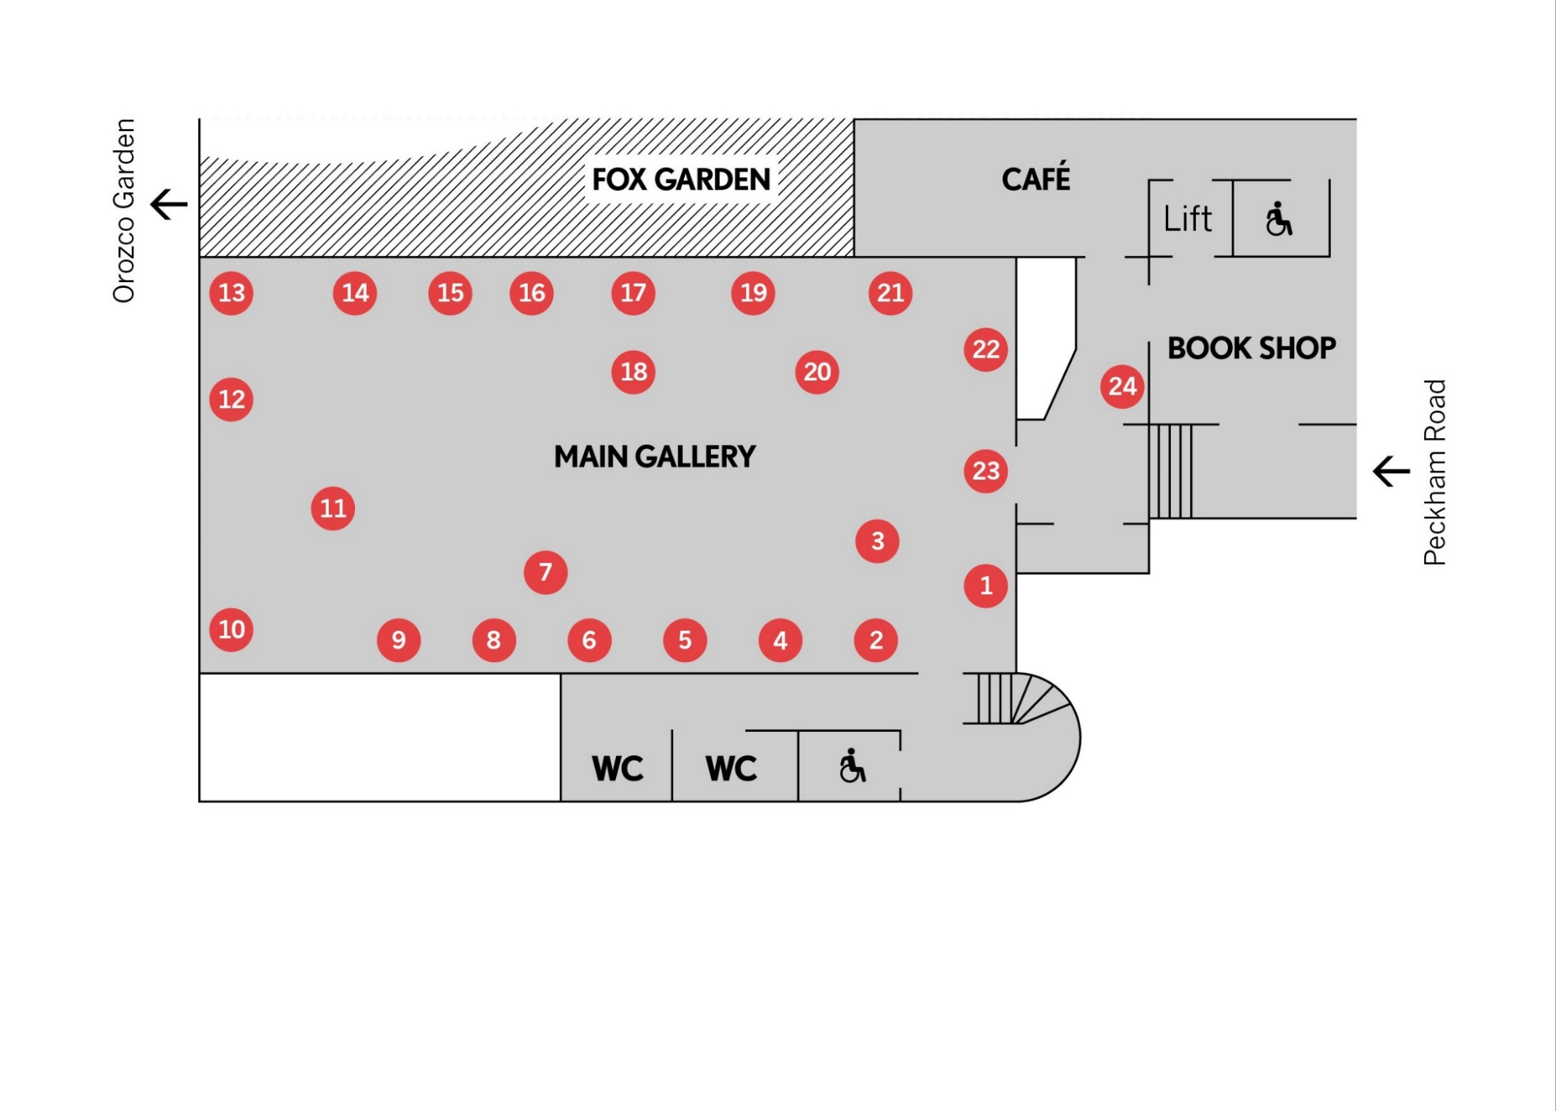
Main Gallery
1. Alexi Marshall
The Party, 2017
Linocut print, Ink on Japanese paper

2. William Glass
Jynx, 2016
Video with audio 11 min. 20 sec.

Two Inches Above The Ground, 2017
16mm converted to HD video 4 min. 15 sec.

3. Panicattack Duo
Nothing Really Mattress, 2018
Durational performance

4. Jack Burton
Hotel, Night Shop, The Smell Of Fig Trees, 2017 Mixed media on linen

5. Richard Ayodeji Ikhide
IYA, 2017
Acrylic ink on paper

6. Francisco Rodriguez
Ghosts, 2017
Oil on canvas

7. Kara Chin
A Chair that Tastes Back, 2018
Wood, laminated plywood, glazed ceramics, acrylic paint and a foam cushion covered with printed upholstery fabric

8. Yuko Obe
Clockwise from top left:
Interconnectivity of Life–Creation, 2017
Interconnectivity of Life – Sun & Moon, 2017
Interconnectivity of Life–Water, 2017
Interconnectivity of Life–Time, 2017
All screen print on paper

9. Ralph Pritchard
Heaven, Hell, 2018
Two-channel video with audio 9 min. 38 sec.

10. Emma Fineman
My Hometown Was Burning and All I Could Think Of Was That Sun Bleached Wall I Pictured in A Dream About The Dominican Republic, 2017
Oil and charcoal on canvas

11. Kobby Adi
The Weight, 2018
Hand-dyed fabric, Commonwealth flag, wood, steel, Nike trainers, Commonwealth Institute pins, Ghanaian cedis, antique mannequin, statue, kimono, reactive digital print on heavyweight canvas, flowers, woven strap, Punch cartoon (1893), articles from The Illustrated London News (1893), image of David Hammons

12. Antonia Showering
Introspective Views, 2017
Oil on canvas

13. Carrie Grainger
The forest has eyes, 2017
Hessian, wood, yarn, plaster, hot melt, horse hair, feathers, twigs and soil

14. Patrick H. Jones
Midday, 2017
Oil on canvas

15. Gareth Kemp
Starry Night//Campfire Light, 2017
Acrylic on canvas

16. Janet Sainsbury
Gleam, 2017
Oil on canvas

17. Rebecca Harper
Stouping, 2017
Acrylic and oil bar on canvas

18. Heidi Maribut
Import In(choir)y, 2017
Mixed media installation

19. Yushi Li
My Tinder Boys–Edric, 24, 13 km away, 2017
C-type print

20. Faye Claridge
Notice Locals, 2018
Freestanding wooden noticeboard containing enlargement from OK! magazine

21. Madelynn Mae
Green Summer ’97, 2018
Oil on canvas
Acquired by the Government Art Collection from New Contemporaries
22. Louis Bennett
The Touch of That Vapour, the Inhaling of Its Pungent Wisps, 2017
Oil on canvas

23. Chris Alton
After the Revolution They Built an Art School Over the Golf Course, 2017
Textiles, wooden dowel

24. Shy Bairns
Shy Bairns Get Contemporary, 2018
Participatory zine workshop

Fire Station

82 Peckham Road
London
SE15 5LQ

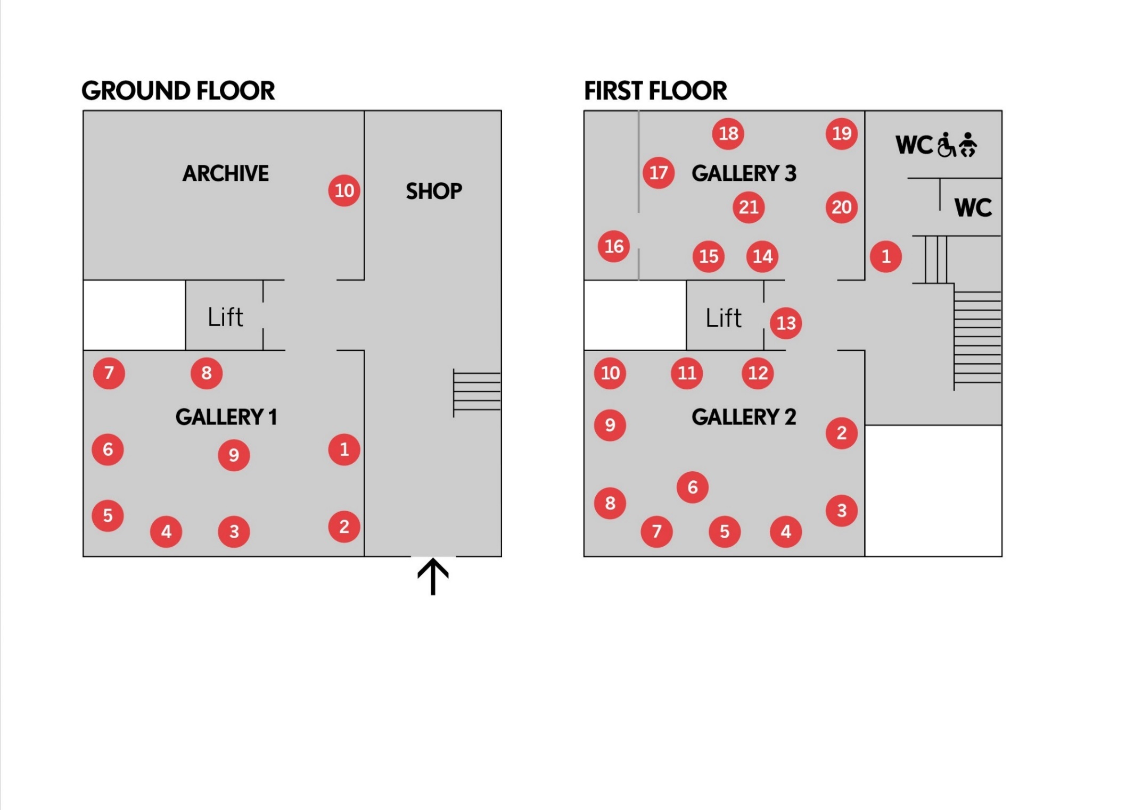

Ground Floor
1. Mohammed Sami
Displacement, 2017
Acrylic on linen
Acquired by the Government Art Collection from New Contemporaries

2. Camilla Hanney
Penance, 2016–17
Hand-burnt fabric

3. Holly McLean
This Is My Sister, 2017
Video with audio 15 min.

4. Jack Fawdry Tatham
I See Her Yet, the Sonsy Queen, 2017
Among the bearded bear, 2017
Both etchings with aquatint and dry point

5. Wal Slzr
Blueprint Double Agent; split film, Eagle, 2017
16mm transferred to video 2 min.

6. Tom Waring
Hurnebaal, 2017
Oil on canvas

7. George Stamenov
Hristo Smirnenski blok.70 entrance A
fl.9 ap.23, Sofia, 1000, 2018
Video with audio 2 min. 34 sec.

8. Maïa Régis
Run Devil Run, 2017
Acrylic, pigments on embroidered linen tablecloth

9. Jocelyn McGregor
The Picnic, 2017
Synthetic hair extensions, oil paint, varnish, plaster, haematite pigment

10. Sam Henty
Eborakon Ofriòr Tapestry, 2018
Embroidery on canvas

First Floor

1. Deme Georghiou
The Blue Tower, 2017
Acrylic on plaster

2. Bella Riza
Salt House, 2017
Video with audio 12 min. 39 sec.

3. Habib Hajallie
Jammer, 2016
Alpha II, 2017
Godfather, 2017
All pen on paper

4. Paula Morison
I Shall Live for 100 Years, 1985–
Performance documented through two websites 100 years

5. FC Izaac
Princess Peach, 2017
Drawing and installation
6. Anna Reading
Economy Class, 2017
Wood, card, expanding foam, wire, gloss paint

7. Ayo Akingbade
Street 66, 2018
Super 16mm, transferred to HD video with audio 13 min. 41 sec.

8. Christian Noelle Charles
CC Time–Do What You Feel Like, 2017
Video with audio 6 min. 42 sec.

9. Kamile Ofoeme
Afro-Glitch, 2017
Giclée print

Gaiden: Black Death, 2017
Audio 8 min. 29 sec.

10. Shao-Jie Lin
Passport to Everywhere, 2017
Recycled paper from expired passport pages from Germany, Japan, Korea, Kuwait, Mauritius, Morocco, Nigeria, Singapore, UK and USA

11. Marianne Keating
Landlessness, 2017
Dual screen video with audio 25 min. 56 sec.

12. Annie-Marie Akussah
Spaces, 2017
Acrylic and silk-screen on board

13. Agil Abdullayev
Rocking my Gucci (Interview with Yves), 2017 Video with audio 15 min. 30 sec.

14. Osian Jenaer
Sorry For This, 2017
Video with audio 7 min. 31 sec.

15. Alcaeus Spyrou
Anina, 2017
Video with audio 19 min. 51 sec.

16. Jessica Jordan-Wrench
I told you there was something in the air, 2017 Installation, 15 min.

17. Yanghwa
A Bright Future, 2017
Acrylic on canvas

18. Rhona Foster
(Just an Egg Sandwich) A Sanctimonious Man, 2018
Video with audio 40 min.

19. Viviana Troya
Hatchery, 2018
Ceramic, acrylic and metal

20. Jack Pell
Columbidae, 2017
Video with audio 11 min. 52 sec.

21. Mimi Hope
Fingers Crossed, 2017
Cast Jesmonite

Related Events

Performances
Panicattack Duo present a durational performance in the Main Gallery every Wednesday, 1–9pm and Saturday,
10am–6pm, with the exception of days when
the gallery is closed over the Christmas period. Please consult the SLG website for details.
Tom Smith and Rosa Johan Uddoh will present solo performances in the SLG’s Clore Studio on 30 Jan from 7pm.
Tickets and more information available from the SLG website.
REcreative Advice Sessions
Sat 19 Jan, 12–5pm, Attic, Fire Station, Free
These informal 1:1 advice sessions for young people are led by a range of professionals working within the creative sector.
This event has been organised by the REcreative Editorial Board to coincide with Bloomberg New Contemporaries 2018 with the aim of inspiring and encouraging young people to work within
the creative sector.
REcreativeuk.com is a free online network for young artists.
Peer Mentoring With Artist Chloe Cooper
Sat 2 Feb, 2–5pm, Clore Studio, Main Building, £5/3 conc.
This talk and participatory session is led by artist and peer mentor, Chloe Cooper. Cooper will introduce the practice of peer mentoring
and its benefits, suggesting ways to establish
groups and models of feedback.
This session is programmed by Artquest in partnership with New Contemporaries.

Writing Into Practice Symposium
Sat 9 Feb, 10.30am doors. 11am–6pm, Camberwell College Lecture Theatre, £5/3 conc.
This day-long event will consider the medium
of writing and the use of language to creatively communicate artistic practices.
This event is a collaboration between New Contemporaries, the South London Gallery
and Camberwell College of Arts.

Publication
The Bloomberg New Contemporaries 2018
publication is available from the SLG Bookshop and the New Contemporaries website, priced at £10.

Selected artworks are for sale. Please enquire at either of the SLG shops for more information.

For more information, or to book any of these events please visit the SLG website: www.southlondongallery.org/whats-on
To request a PDF version of this guide, please talk to reception or contact us on mail@southlondongallery.org

