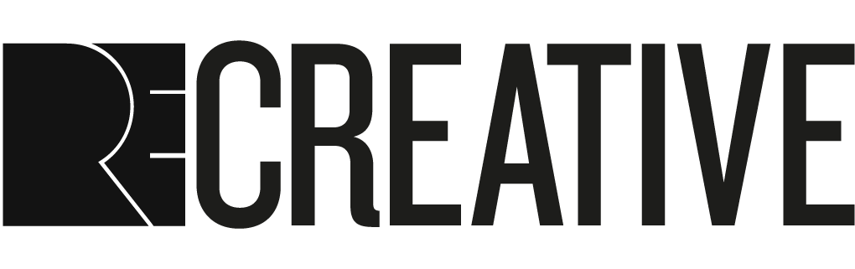
EXHIBITION OPEN CALL: WHAT’S NOT BEING SAID
REcreative Editorial Board invites submissions for an exhibition of work by young creatives aged 14–20 with a connection to Peckham.
The exhibition – titled What’s Not Being Said – will be hosted at the South London Gallery from 22–29 January 2020.
SUBMISSION GUIDELINES
We are looking for creative responses to the question: what’s not being said about Peckham?
However you express yourself – be it through painting, poetry, photography, spoken word, music, dance, performance, sculpture or film – if you have something to say about Peckham, we want to hear from you.
This exhibition offers young people a platform to discuss and question what is happening in your lives and in your communities.
The REcreative Editorial Board will select work from the submissions to be part of the exhibition.
If you have any questions about the open call, please email recreative@southlondongallery.org.
REQUIREMENTS
- Submissions can include existing work, or proposals for new work to be made specifically for the exhibition.
- Applicants must be 14–20 years old.
- Applicants must have a connection to Peckham. This includes people who live or have lived in Peckham, study or work here, or have family here.
- Applicants must not be studying Art at university. However, those studying Curation or Art History, for example, would be eligible to submit work as art-making is not part of their syllabus.

IMPORTANT DATES
- Sat 16 Nov 2019, 11.30am–5pm – Submission help session
If you would like support with your submission, book a free session with the REcreative editorial board to discuss your application. Please email recreative@southlondongallery.org to book a slot.
- Mon 2 Dec 2019, 10pm – Submission deadline
- Mon 16 Dec 2019 – Outcome notification
We will inform those with successful submissions by Mon 16 Dec.
- Wed 22 – Wed 29 Jan 2020 – Exhibition

APPLICATION FORM
Before you begin the application, please ensure you have read the application guidelines carefully

PERSONAL DETAILS
First Name
Surname

Address

Age

Mobile number

Email Address

School/college/work/what I’m currently up to?

ABOUT YOU

Please tell us about your connection to Peckham. (250 words max)
Please tell us what you think is not being said in/about Peckham. (250 words max)

YOUR WORK

Please include with your application up to 3 support materials for the work you would like to submit

For existing work this could include: images, audio recordings, video or writings.

If your work is yet to be made please provide scanned sketches, mood boards and/or a description of the work.

Please do not send any large files as part of your application. Videos or audio should be sent through a link to YouTube link or Soundcloud. If your upload is private please send us the password.
Details
Are you submitting a finished work or a proposal for something new?
What is the title?
What kind of work is it? What medium or materials are used?

Support materials

Link or file name 1
Link or file name 2
Link or file name 3

Please use this space to tell us more about the work you will be submitting for the exhibition. For example the installation or equipment requirements (250 words max)

Email your completed submission form with the subject line ‘WNBS submission’ to recreative@southlondongallery.org by Mon 2 Dec, 10pm. We accept video and voice note submissions for the sections titled ‘About You’ and ‘Your Work’.

Please note that accepted works will need to be dropped off at South London Gallery on 18 January 12 – 2pm

For any further questions please email us at Recreative@southlondongallery.org

