SLG Film School 2020
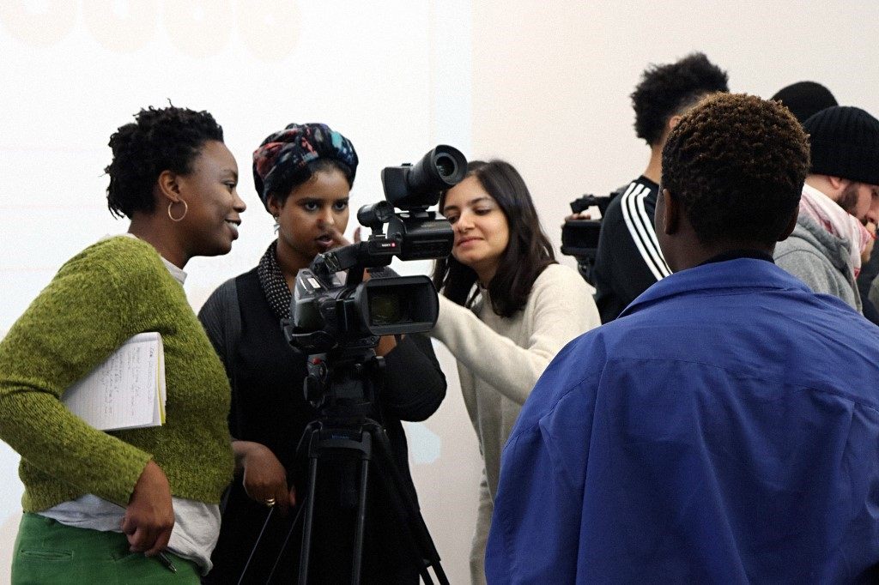SLG Film School 2019. Image credit: Saeed Taji Farouky
Thank you for your interest in the SLG Film School 2020 (formerly known as REcreative Film School) led by Saeed Taji Farouky (Director) and Paul Crook (Young People’s Programme Manager, South London Gallery). The film school will take place on Zoom across five sessions and is aimed at young filmmakers aged 18 - 30. We will also consider applications from those above this age range who are still early in their film career.

The film school sessions explore a range of forms: arthouse / experimental feature film, short films, documentary, music video, essay films and artists’ moving image through practical workshops, practice-development sessions, collaborative story development, and talks by invited specialists working in the industry. The film school aims, above all, to demystify the industry and support participants from under-represented backgrounds to carve out their own space in the filmmaking landscape. The school is dedicated to creating a new generation of filmmakers who are empowered, diverse, fearlessly creative, and who will help build the future of cinema. It enables participants to gain basic practical experience of camera work, learn how to navigate the film industry, develop their unique storytelling voice, and join a supportive group of life-long collaborators.
Participation is free but space on the course is limited. We are looking for students who are lovers of film and are interested in making a career in moving images. We are particularly keen to support applicants who have not yet had access to similar programmes, and those from backgrounds that are underrepresented in the film industry; including those: with Black, Asian or minority ethnic heritage; from low-income backgrounds; who identify as LGBTQ+; who are disabled.

We ask applicants to make this clear when applying, if applicable. Experience isn’t necessary but you need to have a passion to learn about film and a willingness to work together as a group.

Students of the SLG Film School must be able to attend Saturday 7, 14, 21 & 28 November & Saturday 5 December, 11am-4pm.

If you will require any special arrangements at any stage of this process, including making an application by video or audio instead, please contact Paul Crook at paul@southlondongallery.org or telephone 020 7703 6120.

We will notify you by 12 October if your application has been successful.

COVID-19
In light of the recent changes to government coronavirus (Covid-19) guidance, the SLG Film School 2020 will now take place online.

We apologise for any disappointment caused. We will be working on ways to adapt the lessons and offering creative solutions to moving the experience online. As part of these changes, we will be reducing the length of the days to 11am–4pm (GMT) with a one-hour lunch break at 1pm, but the dates will remain the same.

SLG Film School 2020 Application
Please complete the below application and email as a pdf to paul@southlondongallery.org no later than 6pm on Monday 5 October with the subject line: SLG Film School Application 2020. Please fill out the equal opportunities monitoring form here upon submitting your application.
Feel free to expand the boxes but please restrict your answers within the stated word limits.

First Name
Surname

Address

Date of Birth

Mobile number

Email Address

Website

Instagram/ Twitter/ Tumblr/ youtube

What are you currently up to? (School, college, uni, working)

Do you have any creative work online? Please put maximum 3 links to give us an idea of the kinds of things you do. It doesn't have to be film.

How did you find out about the film school?

Why should you gain a place on the SLG Film School 2020? (max 200 words)

Please tell us about any experience that you have making films, and share links of previous films. Experience isn't necessary, but please include training or workshops that you have attended. (max 200 words)

Name a film you love - it doesn't have to be your "favourite" film - and tell us why. (max 200 words)

How do you think you would benefit from the SLG Film School 2020? (max 200 words)

Anything else we should know that would make us even more excited to work with you? (max 200 words)

Are you able to attend all dates?: Saturday 7, 14, 21 & 28 November & Saturday 5 December, 11am-4pm

Have you previously applied for the film school? Y/N If yes, what year?

Equal Opportunities
The South London Gallery is committed to equal opportunities and positively encourages applications from suitably qualified and eligible candidates regardless of gender, race, disability, age, sexual orientation, religion or belief, marriage or civil partnership status, or pregnancy and maternity.
Data Protection
Information provided by you as part of your application, including any special category data, will be used in the selection process and is held and processed by the SLG for legitimate interests pursued by us in the selection process, and as the course provider if you are selected to participate in the course. Any data about you will be held securely with access restricted to those involved in dealing with your application and in the selection process. Once this process is completed the data relating to unsuccessful applicants will be stored for a maximum of six months and then destroyed. If you are selected to participate in the course, your application form will be retained for a maximum of six months after the duration of the course.
Declaration
I declare that the information contained in this application is complete and correct. I understand that if I have knowingly provided false information or withheld relevant details, this will effect my continuation on the project.
Please print or sign your name:
Date:

