PRESS RELEASE

SHAMICA RUDDOCK OPENS DECIPHERING A BROKEN SYNTAX AT SOUTH LONDON GALLERY
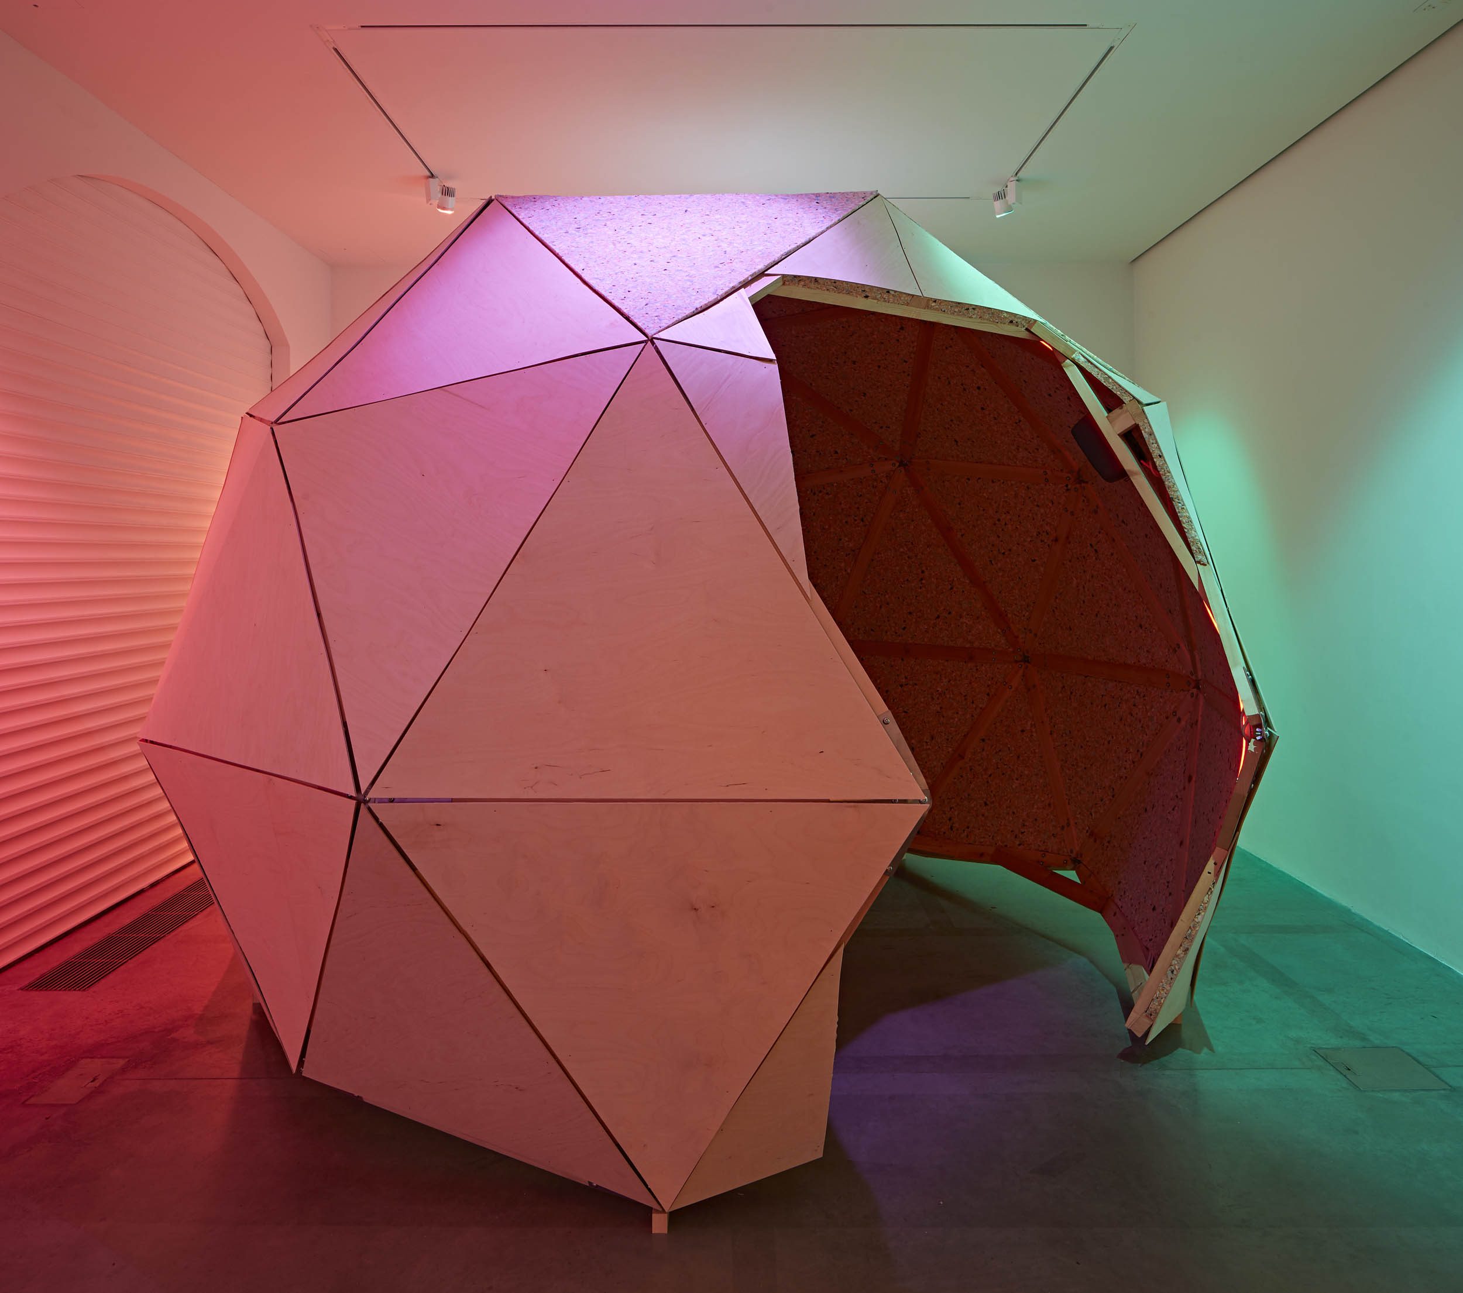
Image Credit: Shamica Ruddock, Deciphering a Broken
Syntax, 2022, Installation View, Andy Stagg

- Shamica Ruddock is the eleventh Postgradute Residency Artist at the South London Gallery and opens Deciphering A Broken Syntax on the 8 April 2022.
- This newly-commisioned sound work is housed within a purpose-built listening environment, offering visitors a chance to travel through sonic and cosmic worlds in a meditative space.
- Shamica’s work investigates Black Technopoetics, the relationship between race, technology and sound, looking at the history of Black sound culture through the narratives of sci-fi and spiritualism.

Exhibition Dates: 8 April – 12 June 2022
Download images here.

The South London Galley's eleventh Postgraduate Residency Artist, Shamica Ruddock will exhibit Deciphering A Broken Syntax at the Fire Station Gallery 1, until 12 June 2022. This free exhibition is the result of a six months residency at the Camberwell-based gallery and consists of a sound work housed within a purpose-built listening environment.

This newly-commissioned installation by Shamica is research-driven and involves sound, lighting and installation. Their practice considers the ways in which Black diasporas are engaged and explored through sound, where sound becomes a form of narrativising. Visitors can travel through sonic and cosmic worlds via the 30-minute soundscape in this meditative space.

Shamica is a research-based artist often working between sound, text and moving image. During the residency, they continued to investigate Black Technopoetics, the relationship between race, technology and sound, looking at the history of Black sound culture through the narratives of sci-fi and spiritualism.

As a starting point for the exhibition, Shamica considered the structure of a vinyl record, taking the record sleeve, liner notes and the record itself as inspiration to think about sound spatially. Outside of the gallery space, the Fire Station windows will show diagrams produced from Shamica’s research. A vinyl record including sounds from the installation and inserts that hold contextual cues will be distributed during the exhibition’s run.

Shamica uses sound as a means of transportation through time, cultures, and space. Their use of drum patterns in the audio work points to the long history of Black sound culture and music production. Working with funk and disco drum pattern books from the 1960s and 1970s, they have drawn from various forms of Black sound culture to collapse different temporalities into the present.

Inspiration for the shape of the listening dome comes from a bulbous fruit called the calabash gourd. For at least 10,000 years, the calabash, or bottle gourd, has been used in African-Caribbean cultures to eat, create domestic objects and musical instruments. It also has spiritual significance related to cosmogony, the branch of science that deals with the origin of the universe, especially the solar system.

The Postgraduate Residency is supported by the Paul and Louise Cooke Endowment.

ENDS

For further press information, images and interviews please contact Rebecca Butler at Sutton: rebecca@suttoncomms.com | +44 (0)20 7183 3577

NOTES TO EDITORS

Address and Opening Hours
South London Gallery, Main Building
65–67 Peckham Road, London, SE5 8UH

South London Gallery, Fire Station
82 Peckham Road, London, SE15 5LQ

Opening Hours
The Gallery is open Tue – Fri 11am-6pm, Sat and Sun 10am-6pm.
Late opening: every Wed and last Fri of the month until 9pm.
Free entry, all welcome.
www.southlondongallery.org

Social Media
Twitter: @SLG_artupdates
Instagram: @southlondongallery
Facebook: South London Gallery

About Shamica Ruddock

Shamica Ruddock recently completed Open School East Associates Programme and has studied at Kings College, London and the University of California, Los Angeles.

Previous presentations include Margate NOW Festival, Margate, UK, New Contemporaries South London Gallery, London, UK and Treasure Hill Artist Village, Taipei, Taiwan. Ruddock has received the Flamin Fellowship, Film London; the Eccles Centre Visiting Fellowship, with The British Library; a Jerwood Creative Bursary, Jerwood Arts and the Francis Chagrin Award, Sound and Music.

The Postgraduate Residency is supported by the Paul and Louise Cooke Endowment.
About the South London Gallery
The South London Gallery (SLG) was founded in the 19th century by philanthropist William Rossiter to ‘bring art to the people of south London’. Today the gallery comprises its original site at 65 Peckham Road; the Fire Station which opened to the public in 2018; Art Block, a space for local children and families on Sceaux Gardens Estate and two permanent gardens.

The SLG has an international reputation for its’ contemporary art exhibitions by established, mid-career and younger artists and programme of film and performance events. It’s highly regarded, free education programme includes a peer-led young people's forum; family workshops; artist-led projects and commissions on local housing estates; and a BBC Children in Need-funded programme for looked after children.

The South London Gallery is a registered charity and raises more than half of its income from trusts and foundations, sponsors and fundraising events. Its core funders are Arts Council England, Freelands Foundation and Southwark Council.

